**MVISION EDR**

*Creating Custom Reaction to Submit Sample to ATD*

**Create a User on ATD Appliance to Submit Samples**

1. Login to ATD Appliance go to Manage
2. Select ATD Users and click New
3. Enter username and password select user type Stand Alone
4. Select the Web Access and Restful Access Roles and click save

**Modify PowerShell Script to input ATD address and username and password**

**Edit the .txt file embedded here **

**To input your ATD information**

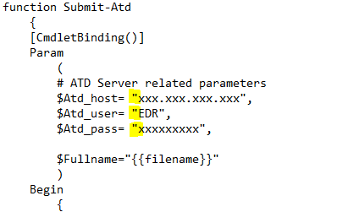

**Put the script into MVision EDR as custom reaction**

Copy the edited script

Navigate to catalog>reactions

Select Windows>Execute PowerShell command

Click new then copy script into reaction window

Add argument filename and select string.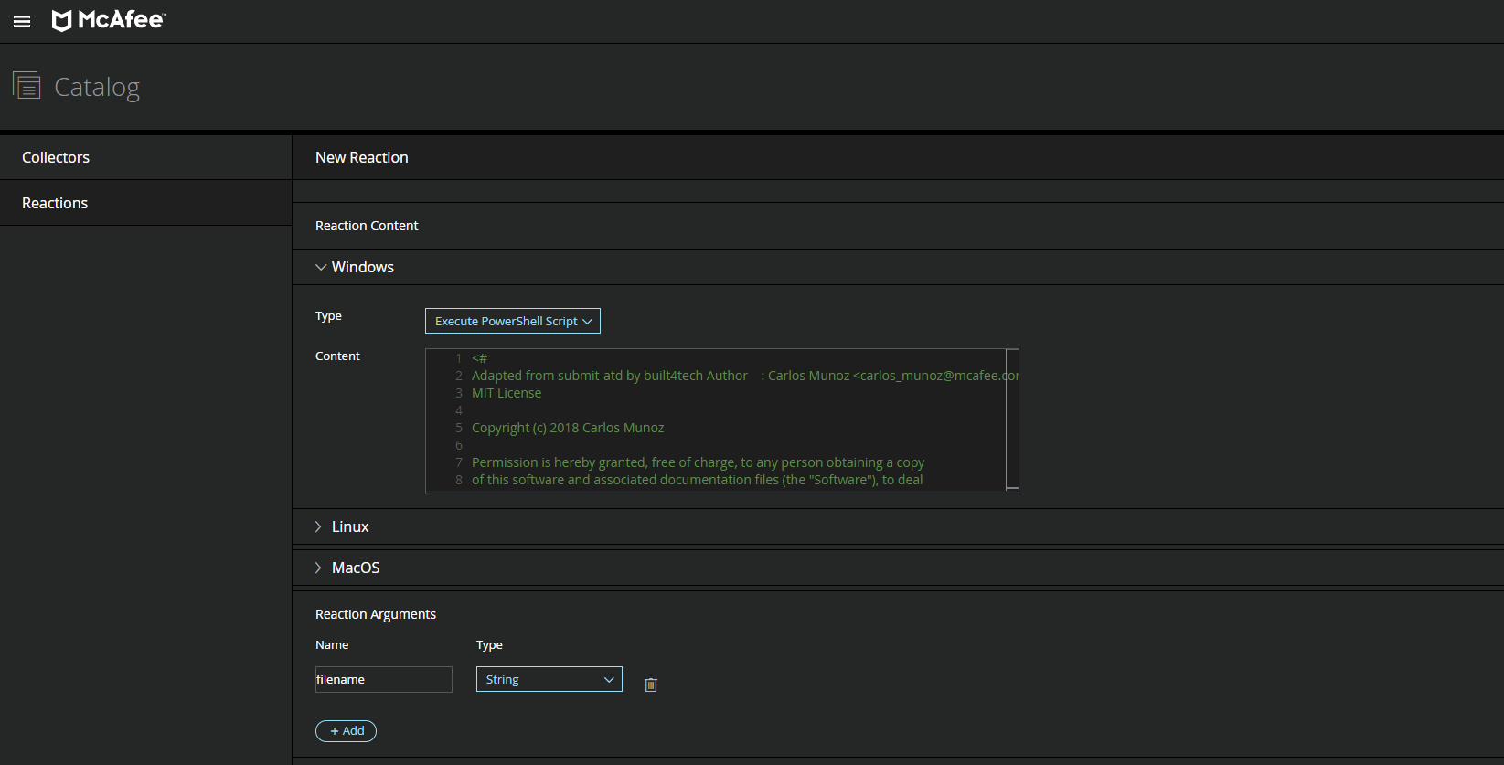

Input Reaction argument filename and type String

You can now submit files to ATD from the real time Search by using the Full filename

